**Vaccine Tracker Application:**

To run the application:

1. Unzip the folder - vaccine-tracker.zip.
2. Open command prompt in the unzipped location 🡪 npm install 🡪 npm start.

**NOTE** – Please use npm 7.0.15 or above.

Once the app loads, we will see this screen,

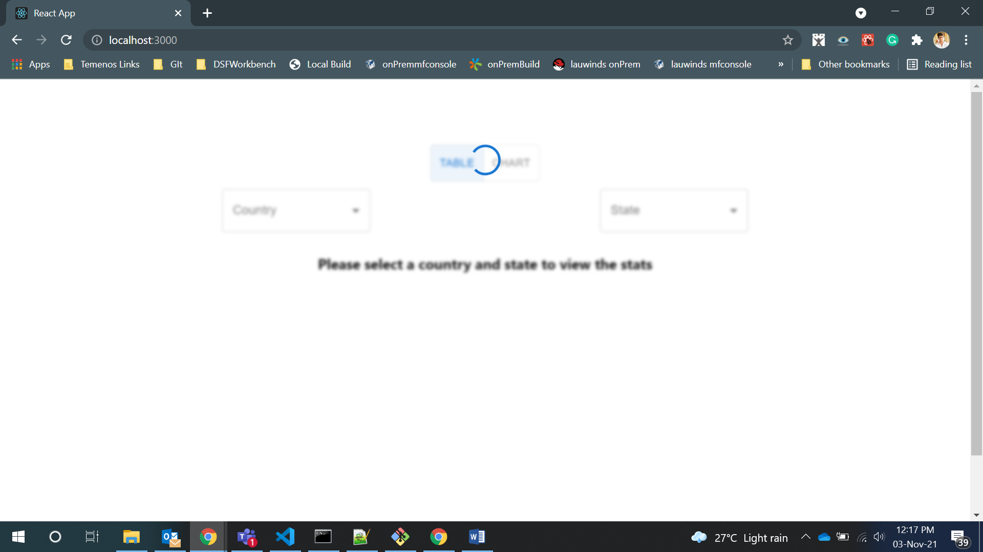

API call has been mimicked and we see the spinner until the API call is done. Once it gets competed we see this screen.

State Management handled using **Redux**.

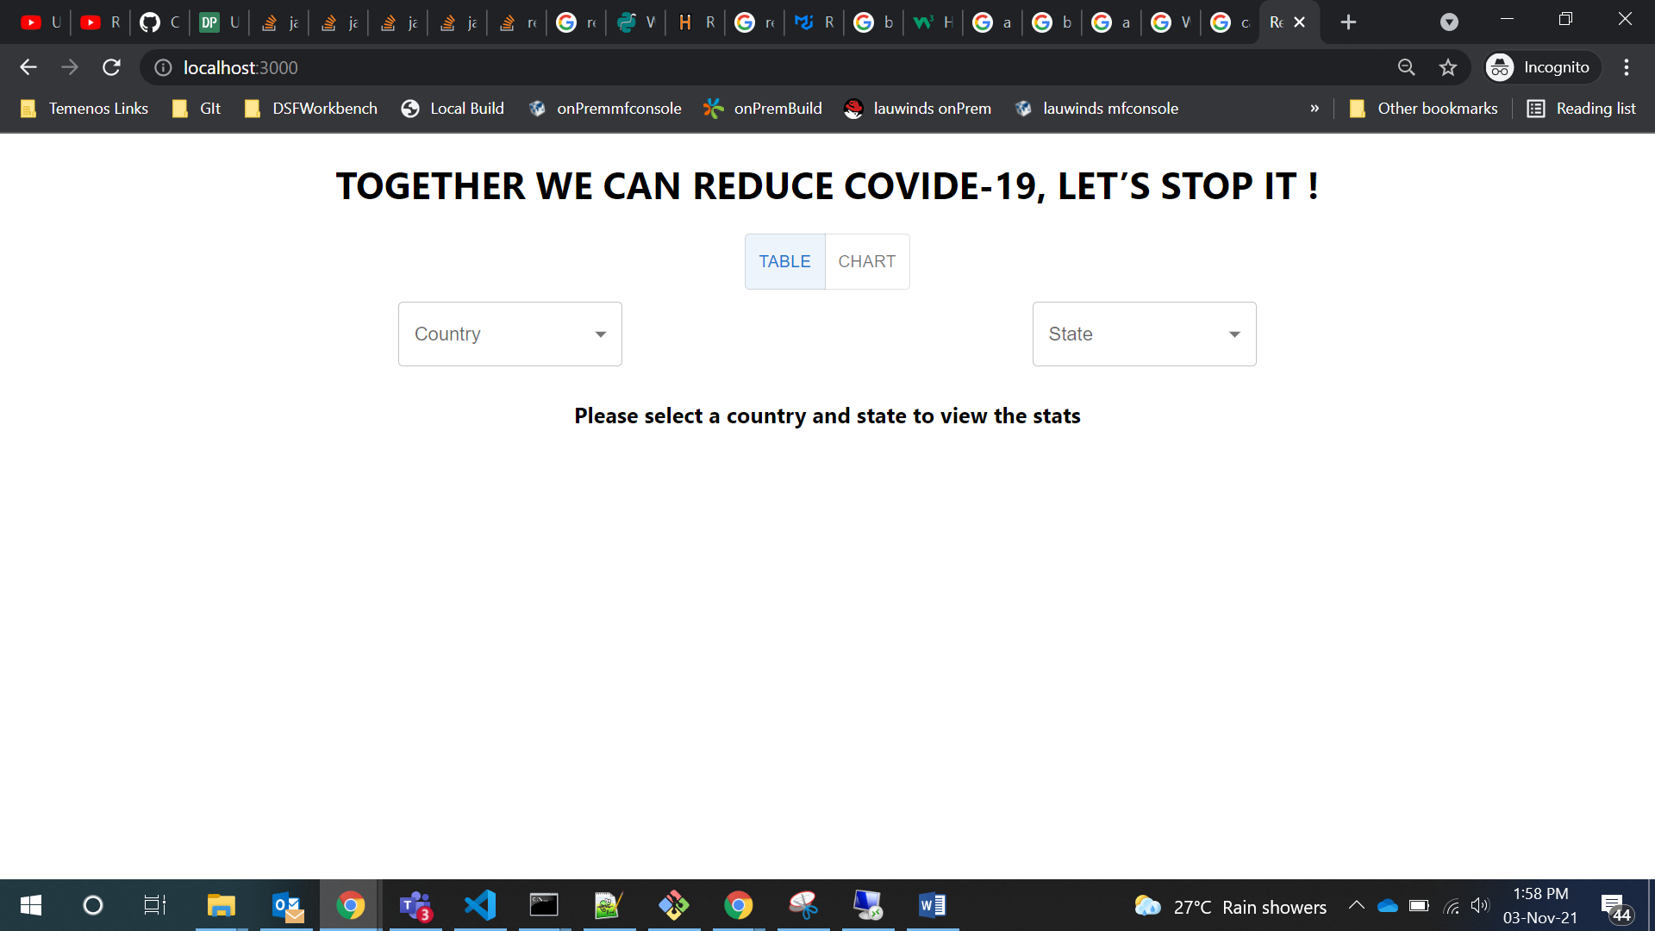

We can select the country from the country selection box. Depending on the country selected the values in the State selection box gets updated.

By default the Table view will be selected. Once we select the country and state the table data will be displayed.

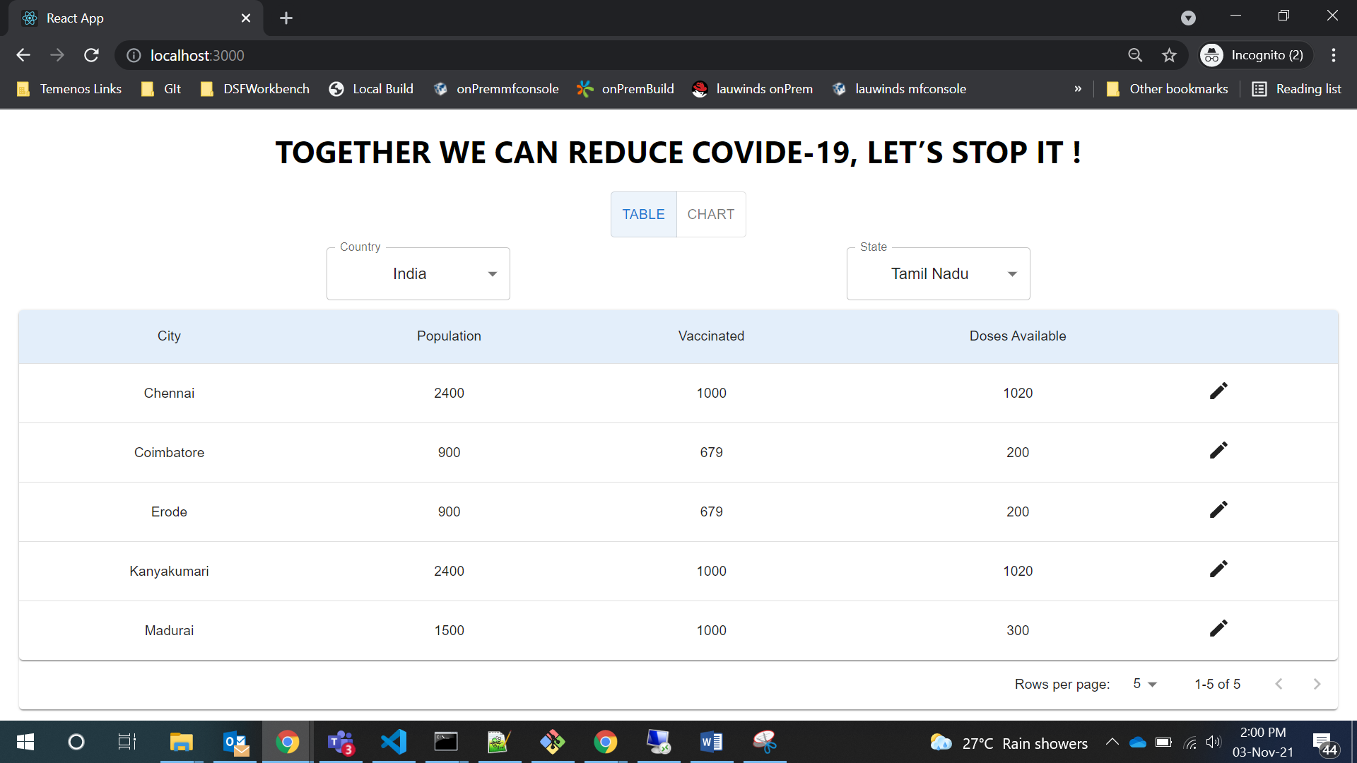

We can switch the view using the toggle option. Chart view will look like this.

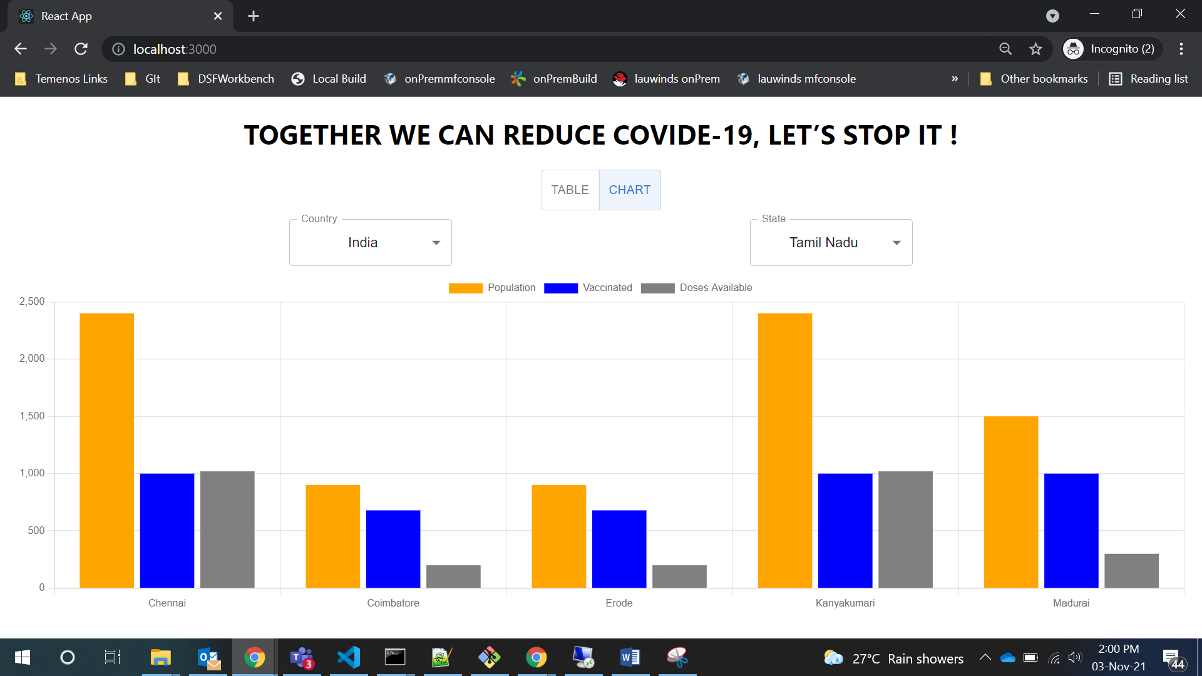

We can click on the legend to select / unselect the data from the chart view.

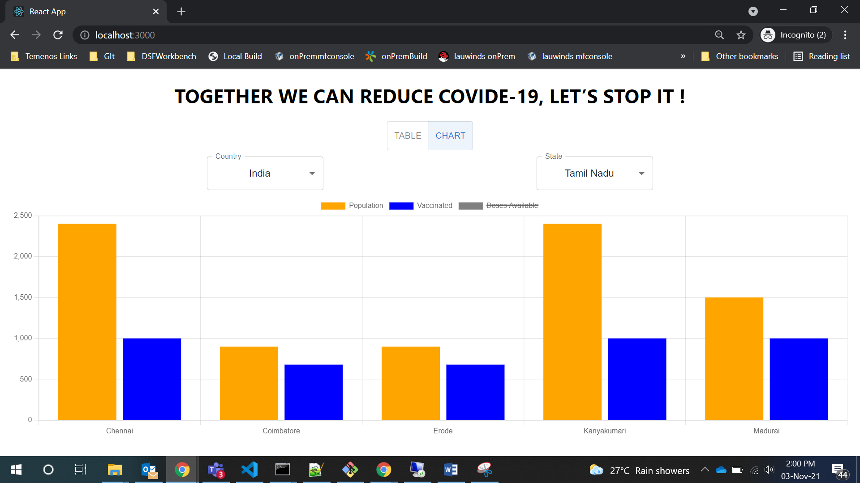

Page-2

When we click on the edit icon on the table we get navigated to the second page.

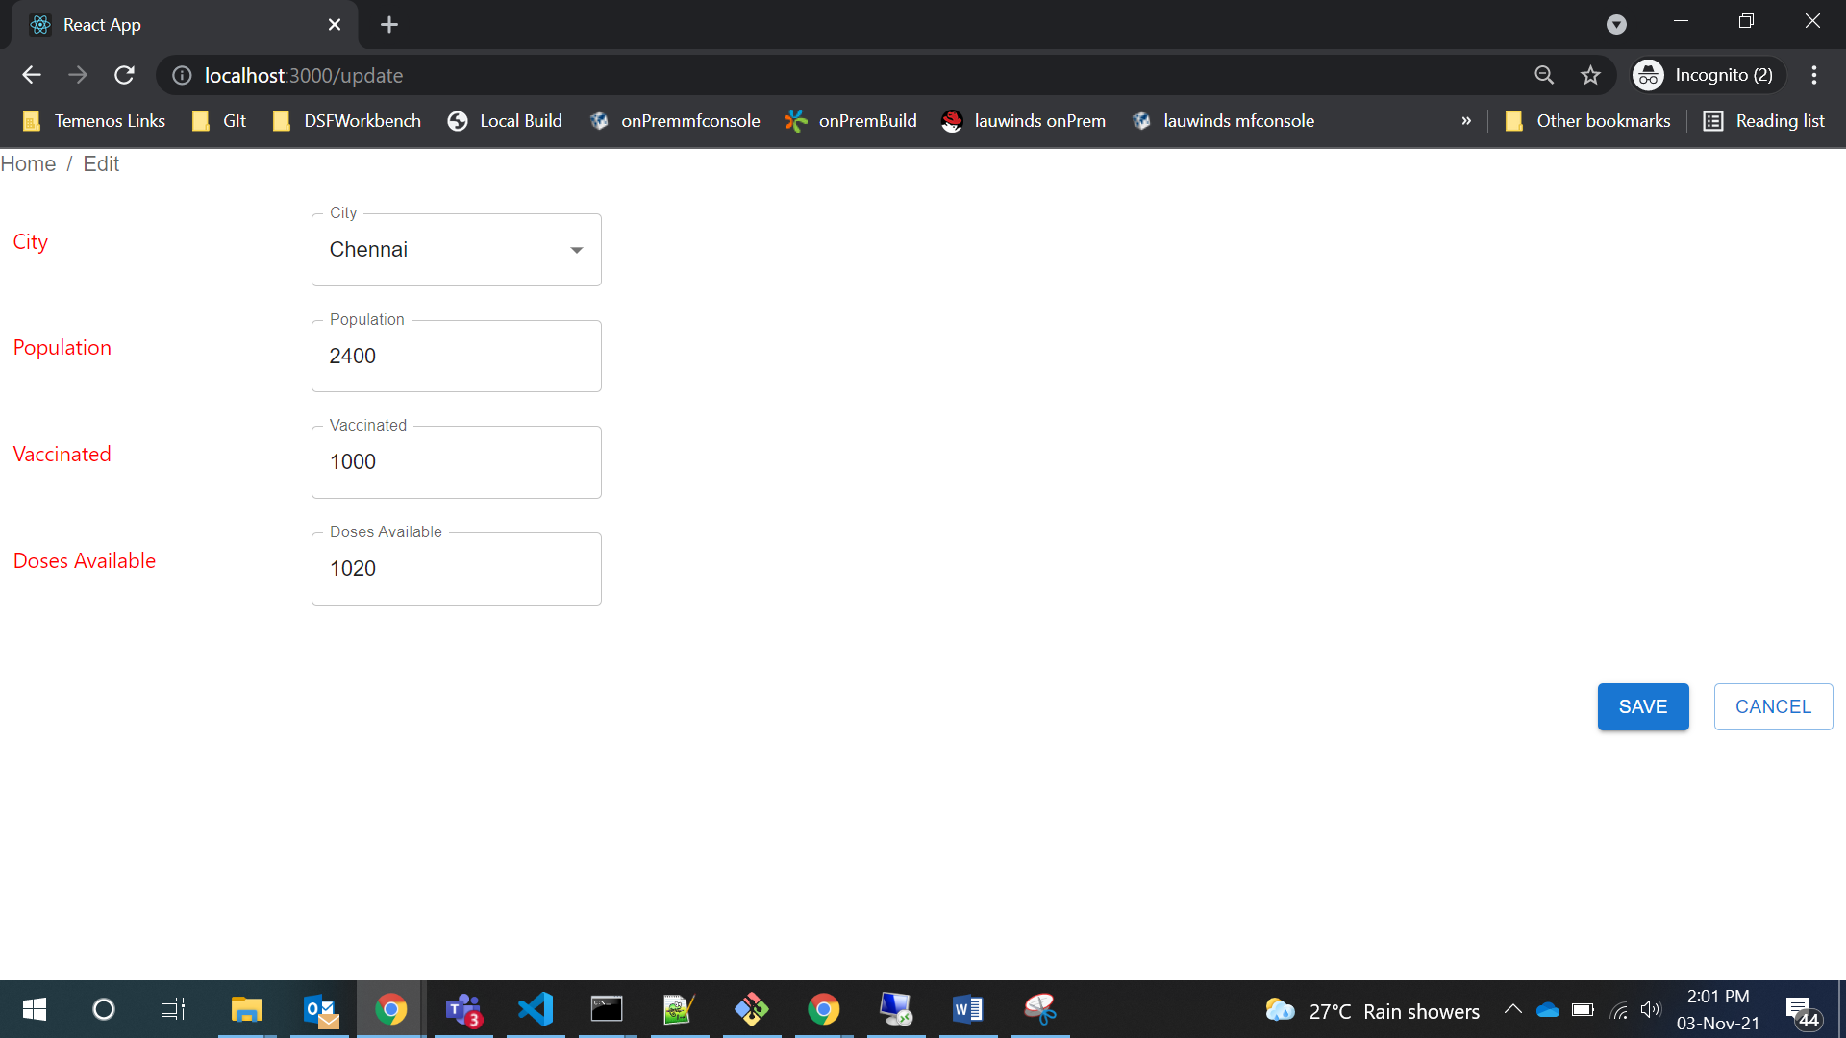

We can update the data and click save which shows confirmation message on success transaction.

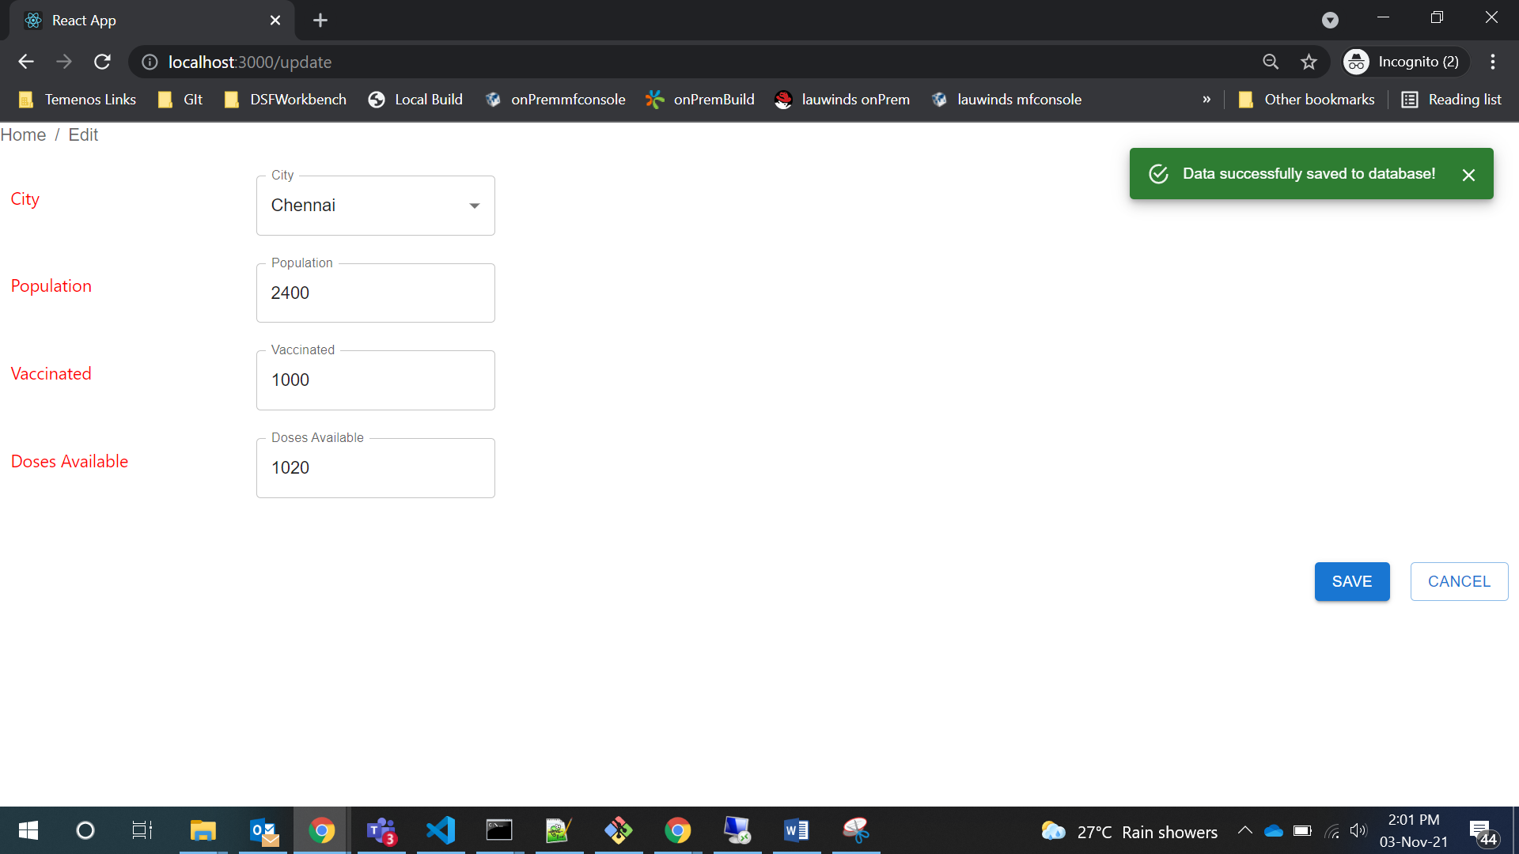

If we click cancel, we get a confirmation popup.

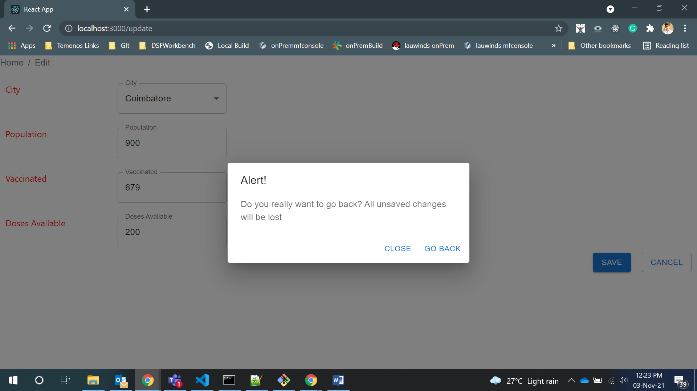

Clicking on “Go Back” will take us to the first page.

**Responsive feature:**

Laptop Breakpoint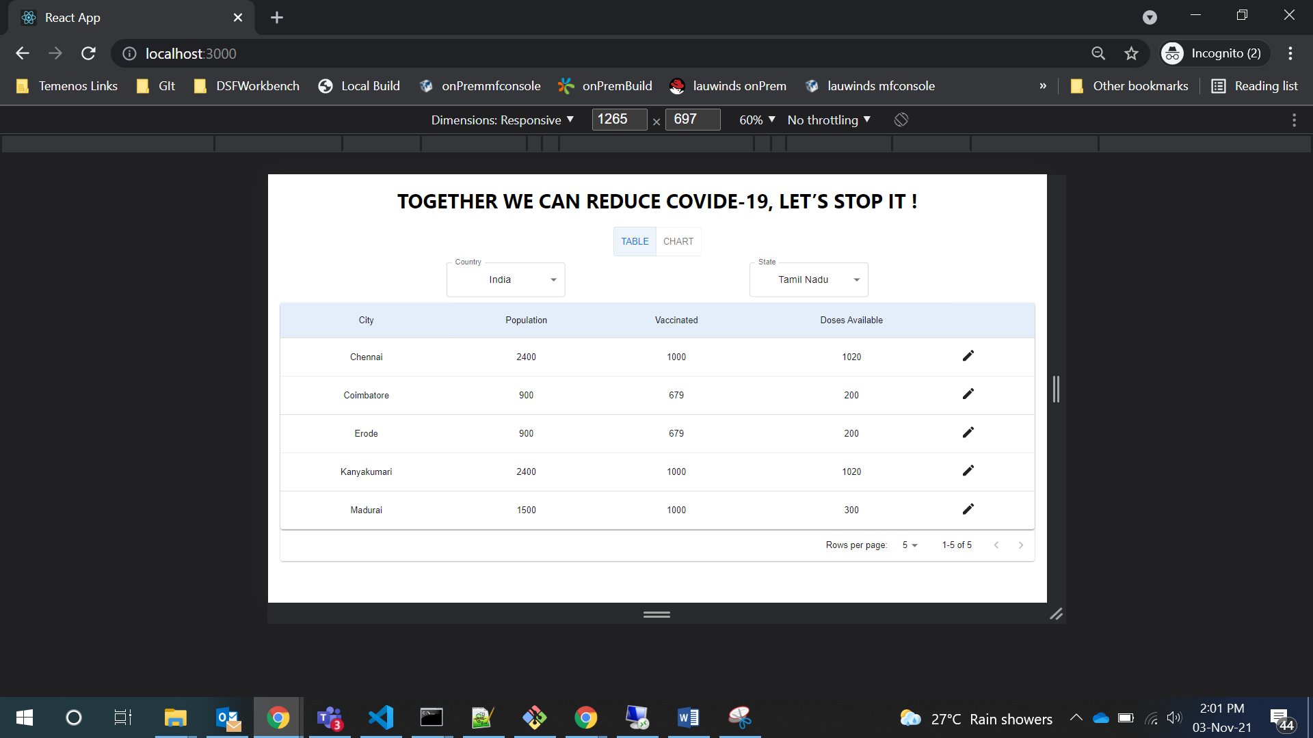

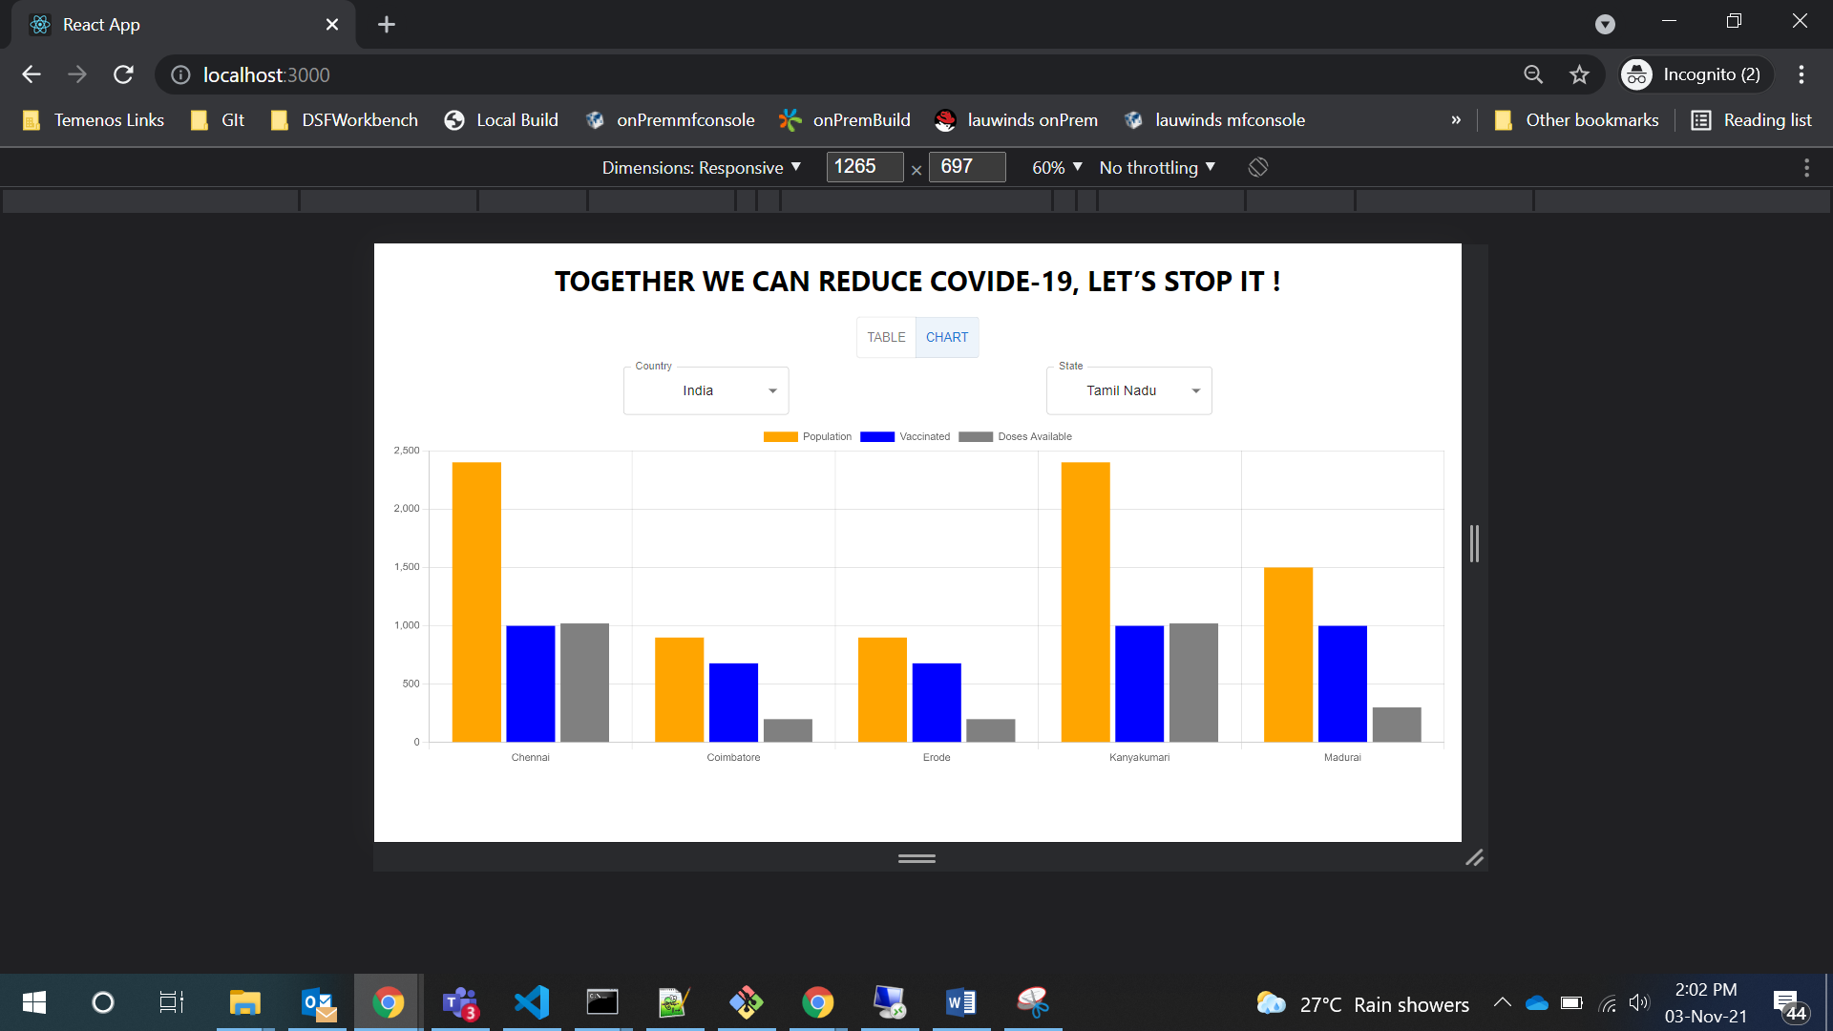

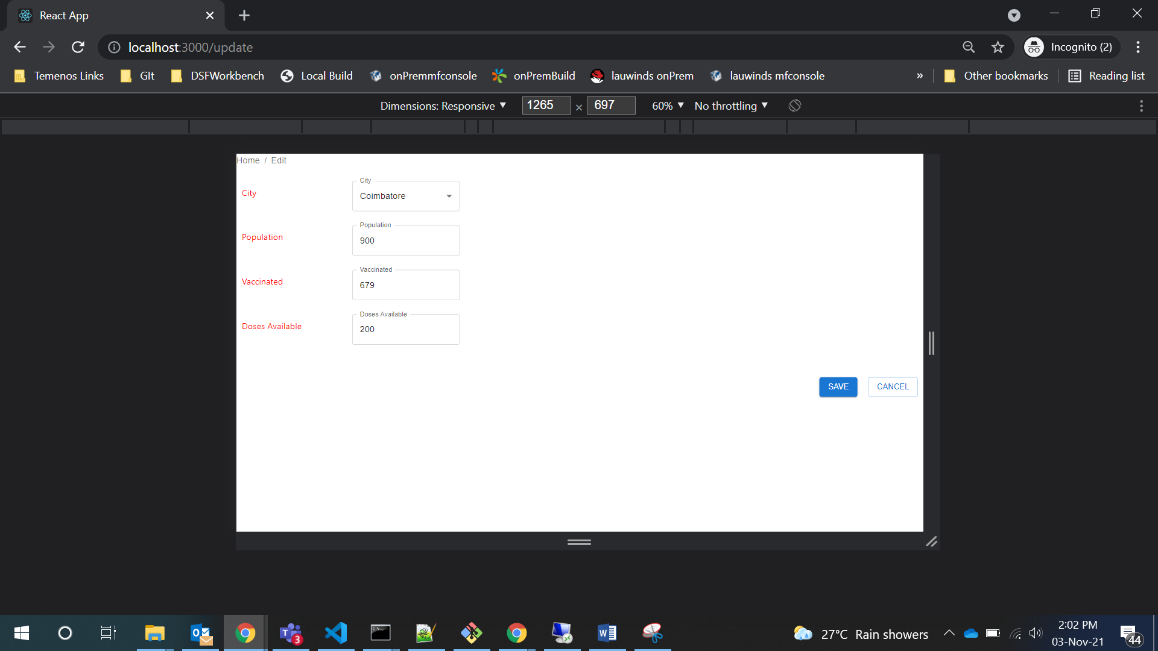

Tablet Break point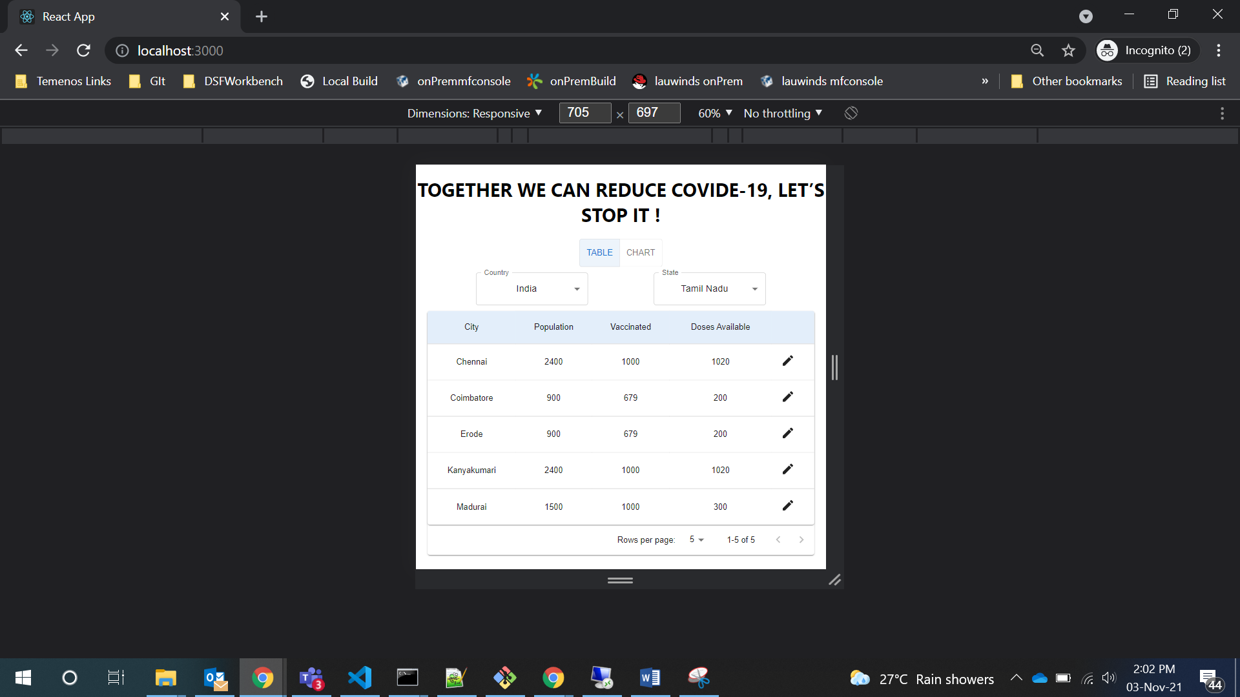

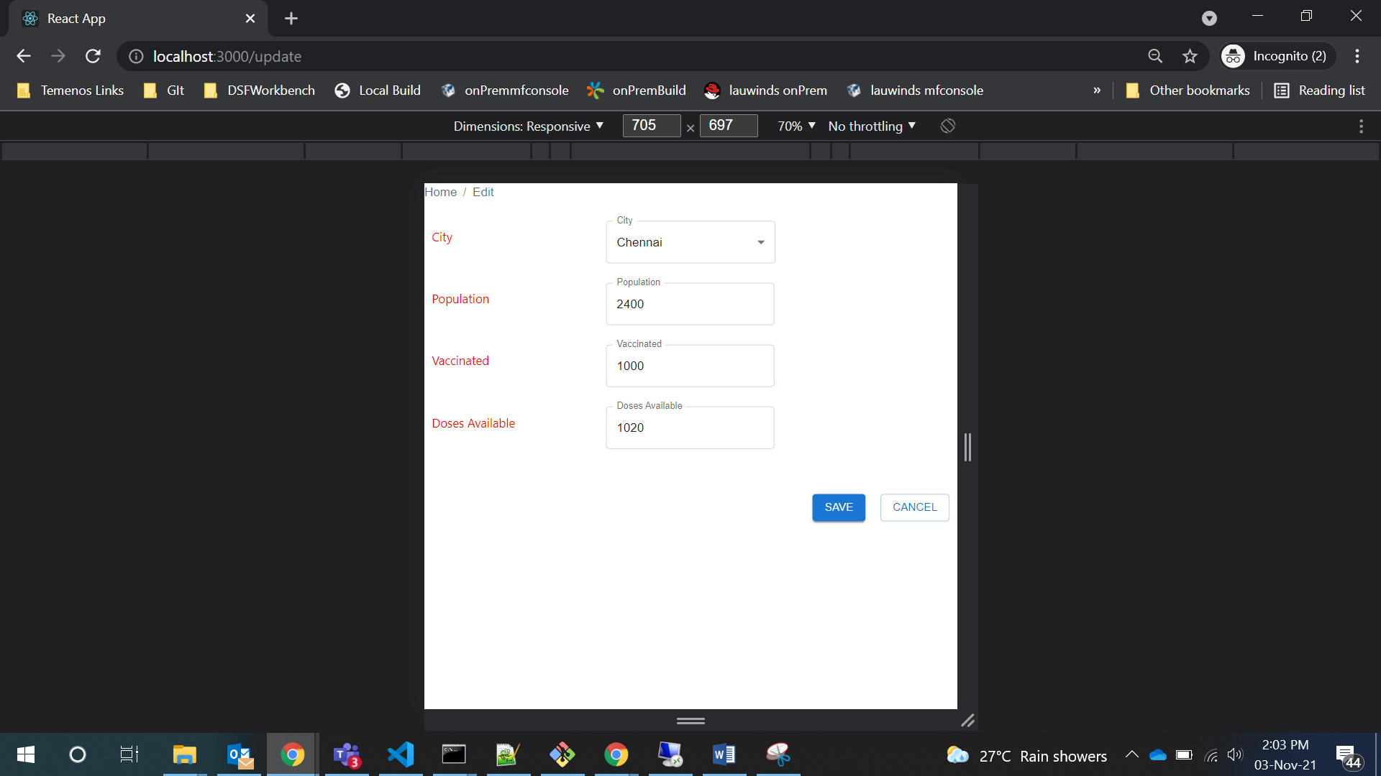

Mobile Breakpoint